Đinh Trọng Đạt 1914775

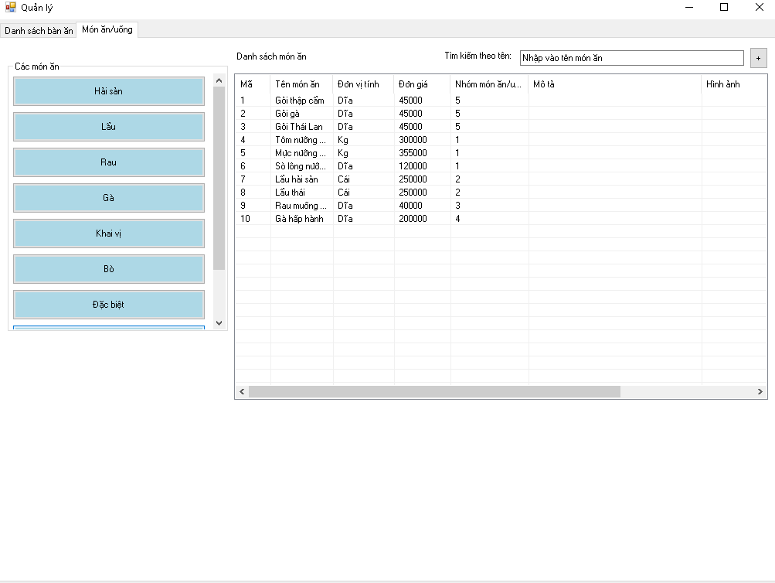

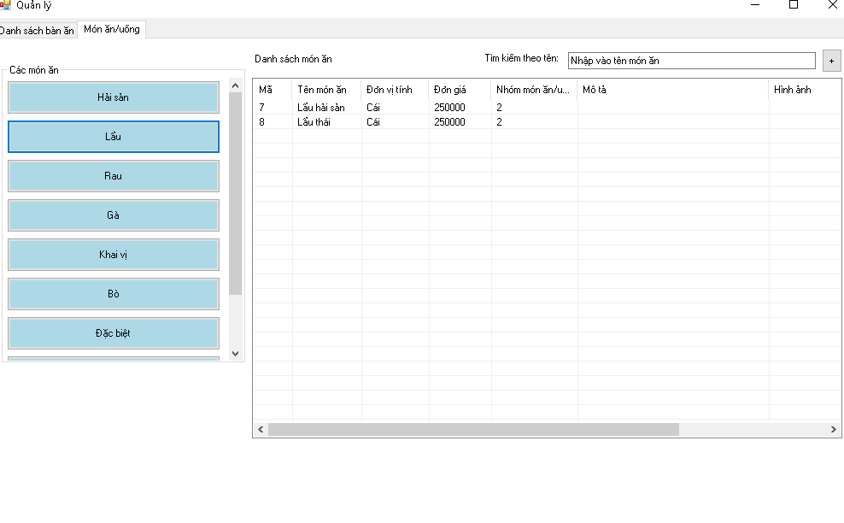

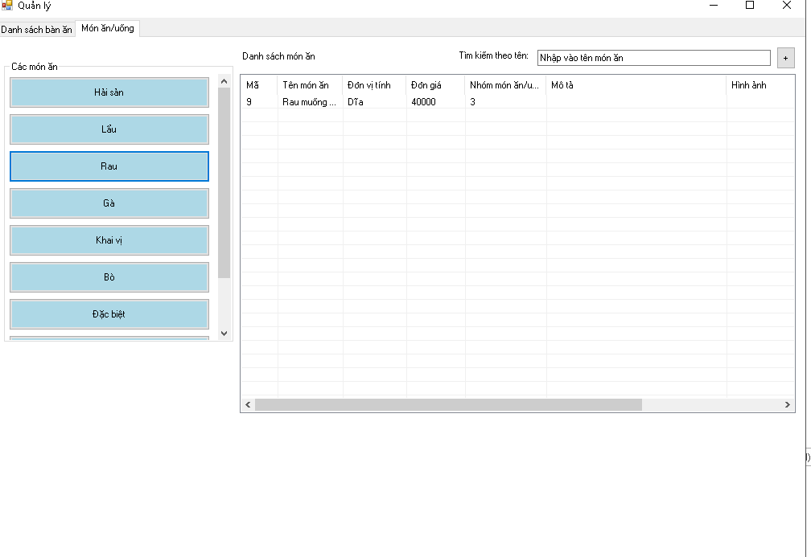

private void AdminForm_Load(object sender, EventArgs e)

{

LoadTableToLvDetail();

LoadTableFoodDetail(WorkingContext.FoodList);

LoadCategory();

SetUpSearch();

}

private void LoadTableFoodDetail(List<Food> list)

{

lvFoodList.Items.Clear();

foreach (var food in list)

{

ListViewItem item = new ListViewItem(food.Id.ToString());

item.SubItems.Add(food.Name);

item.SubItems.Add(food.Unit);

item.SubItems.Add(food.UnitPrice.ToString());

item.SubItems.Add(food.CategoryId.ToString());

item.SubItems.Add(food.Description);

item.SubItems.Add(food.ImageLink);

lvFoodList.Items.Add(item);

}

}

private void LoadCategory()

{

foreach (var cat in WorkingContext.CategoryList)

{

int id = cat.Id;

Button btn = new Button();

btn.Text = cat.Name;

btn.BackColor = Color.LightBlue;

btn.Height = 40;

btn.Width = 250;

btn.Tag = id;

btn.Click += CategoryBtn_Click;

flpCategory.Controls.Add(btn);

}

}

private void CategoryBtn_Click(object sender, EventArgs e)

{

int _currentCategory = Convert.ToInt32((sender as Button).Tag);

var foods = WorkingContext.FoodList;

if(_currentCategory > 0)

{

foods = foods.Where(f => f.CategoryId == _currentCategory).ToList();

}

LoadTableFoodDetail(foods);

}

private void SetUpSearch()

{

txtSearch.Text = "Nhập vào tên món ăn";

txtSearch.GotFocus += RemovePlaceHolderText;

txtSearch.LostFocus += ShowPlaceHolderText;

}

private void ShowPlaceHolderText(object sender, EventArgs e)

{

if (string.IsNullOrWhiteSpace(txtSearch.Text))

txtSearch.Text = "Nhập vào tên món ăn";

}

private void RemovePlaceHolderText(object sender, EventArgs e)

{

if (txtSearch.Text == "Nhập vào tên món ăn")

txtSearch.Text = "";

}

